Project Design Phase-II

Data Flow Diagram & User Stories

|  |  |
| --- | --- |
| Date | 03 October 2022 |
| Team ID | NM2023TMID08265 |
| Project Name | AQUATIC INSIGHTS: COGNOS -POWERED WATER PORTABILITY ANALYSIS |
| Maximum Marks | 4 Marks |

# Data Flow Diagrams:

A Data Flow Diagram (DFD) is a traditional visual representation of the information flows within a system. A neat and clear DFD can depict the right amount of the system requirement graphically. It shows how data enters and leaves the system, what changes the information, and where data is stored.

# Data Flow Diagram:

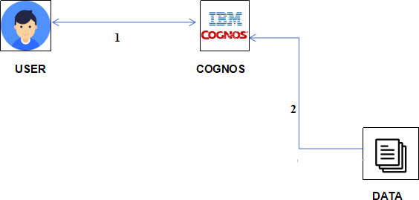

**User Stories**

Use the below template to list all the user stories for the product.

|  |  |  |  |  |  |  |
| --- | --- | --- | --- | --- | --- | --- |
| **User Type** | **Functional**  **Requirement (Epic)** | **User Story Number** | **User Story / Task** | **Acceptance criteria** | **Priority** | **Release** |
| Customer (Mobile user) | Registration | USN-1 | As a user, I can register for the application by entering my email, password, and confirming my password. | I can access my account / dashboard | High | Sprint-1 |
|  |  | USN-2 | As a user, I will receive confirmation email once I have registered for the application | I can receive confirmation email & click confirm | High | Sprint-1 |
|  |  | USN-3 | As a user, I can register for the application through Facebook | I can register & access the dashboard with Facebook Login | Low | Sprint-2 |
|  |  | USN-4 | As a user, I can register for the application through Gmail |  | Medium | Sprint-1 |
|  | Login | USN-5 | As a user, I can log into the application by entering email & password |  | High | Sprint-1 |
|  | Dashboard |  |  |  |  |  |
| Customer (Web user) | Registration | USN-6 | As a web user, I can register for the application by providing my email, password, and confirming the password. | I can access my account / dashboard. | High | Sprint-2 |
| Customer (Web User) | Login | USN-7 | As a web user, I can log into the application by entering my email & password. | I can access my account / dashboard | High | Sprint-1 |
| Customer Care Executive | Dashboard | USN-8 | As a Customer Care Executive, I can access a dashboard that provides an overview of customer queries and issues. | I can view and manage customer queries and issues. | High | Sprint-2 |
|  | Dashboard | USN-9 | As a Customer Care Executive, I can search for specific customer queries using filters. | I can search for queries based on filters. | Medium | Sprint-2 |